Food Truck Business Plan
Provided by The SMB Guide
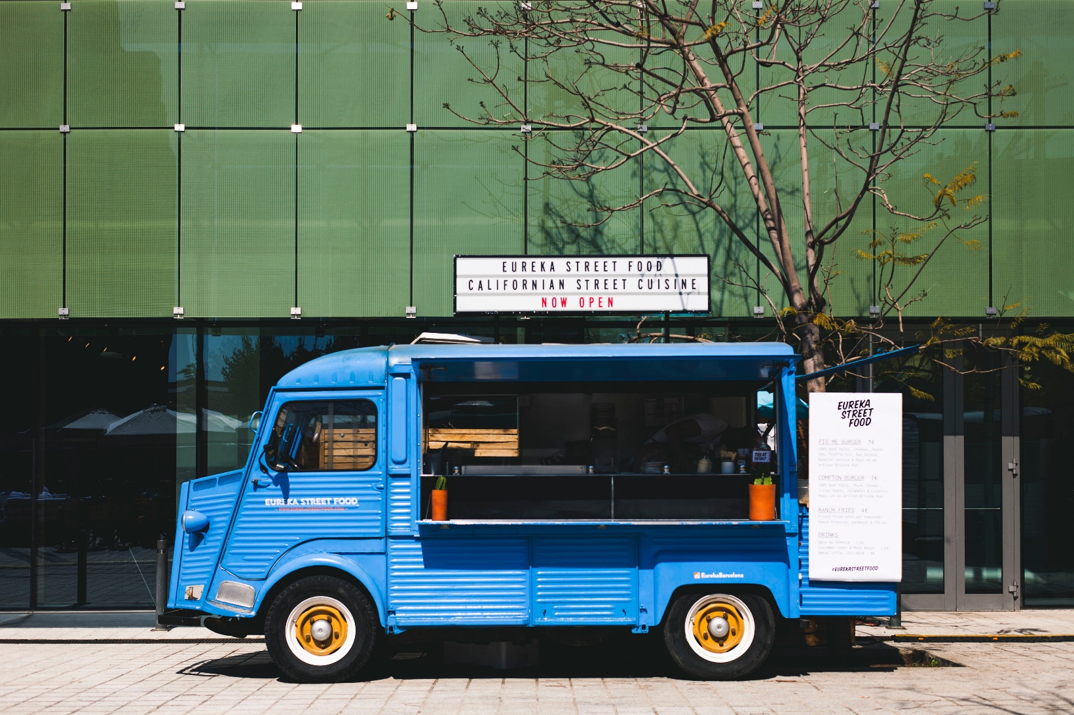

Table of Contents
Executive Summary 3
Mission Statement 3
Distinctives 3
Investment Opportunities 3
Business Description 3
Legal Structure 3
Location 3
Launch 4
Sources of Revenue 4
Operations & Management 4
Leadership 4
Front of House Operations 4
Marketing 5
Food Style 5
Target Market 5
Promotional Outlets 5
SWOT Analysis 5
Competition 5
Financials 6
Startup Expenses 6
Sources of Funding 6
Financial Operations 6
Revenue Projections 6
Break Even Point 6
Pro Forma Profit and Loss Statement 6
Future Plans 6

Executive Summary
[Name of business] is a new food truck that will be established in [city/town] by founder(s) [list of founders. We aim to provide quality [product served] to the community.

Initially, [name of business] will be supported by a personal investment from each of the founders and a business loan that will be used to secure a food truck and equipment.

Mission Statement
“[Business name] exists to provide quality food made of only locally-sourced organic and free-range ingredients, supporting local agriculture and small businesses.”

Distinctives
- Only locally-sourced ingredients are used.
- All ingredients are organic and free-range.
- All utensils and serving materials are 100% recyclable.

Investment Opportunities
Although [business name] has enough capital to begin operating on a small scale, capital from private investors in the food truck will be needed to purchase additional equipment, purchase more trucks, and hire more employees. This will be achieved through a combination of loans and equity partnerships.

Business Description
Legal Structure
[Business name] has been established as a Limited Liability Company in the state of [State name]. [Name] is the attorney of record.

Location
A location for [Business name] has been chosen based on our target market and legal availability outlined by the county clerk. We have chosen to park our truck in [area] because of the foot traffic, relative safety and demographic of the area.

Launch
Pending finances, [business name] will tentatively open its doors to customers on/in [note specific date or month with year].
Sources of Revenue
[Business name’s] primary source of revenue will be derived from selling food. We will also sell local craft beer.

Operations & Management

Leadership
CEO/Owner – [Name and brief bio]
Head Cook – [Name and brief bio]

Front of House Operations
Head Cook – The Head Cook will prepare meals for customers and assist with creating and updating menus.

Marketing

Food Style
We will be making healthy alternatives to fast food dishes like burgers and fries by using organic and free-range ingredients.

Target Market

Promotional Outlets
    - Social Media
    - Collaborative Markets/Events
    - Press/Media Coverage
    - Loyalty Incentives (such as a discount after x number of purchases)
    - Merchandise (such as clothing items with your logo)
    - Local Ingredients

SWOT Analysis
    - Strengths
    - Weaknesses
    - Opportunities
    - Threats
    - Summary
Strengths | Weaknesses | Threats | Opportunities

Competition
In the state of [state name], there are [number] food trucks. More specifically, within the local market of [city/town/municipality/county] we have identified [number] existing food trucks:

- [Food truck name] – Brief description.
- [Food truck name] – Brief description.
- [Food truck name] – Brief description.

Financials

Startup Expenses

Sources of Funding
Use our Sources and Uses spreadsheet to complete this section.

Financial Operations
- Parking Permit
- Hours of Operation
- Staffing
- Professional Services
- Cost of Meals Sold

Revenue Projections

Break Even Point
[Food truck name] will break even when it achieves sales of [$] per month.
Pro Forma Profit and Loss Statement
Use our Pro Forma Profit and Loss spreadsheet to complete this section.

Future Plans
You can use this section to describe any plans that you have for expansion once your food truck has covered all opening costs and is able to maintain a strong cash flow from one month to the next.

Future plans may include:
- Hiring more staff
- Adding more meals to your menu
- Expanding your number of trucks
- Purchasing more equipment to increase your production capacity

