Brewery Business Plan
Provided by TheSMBGuide
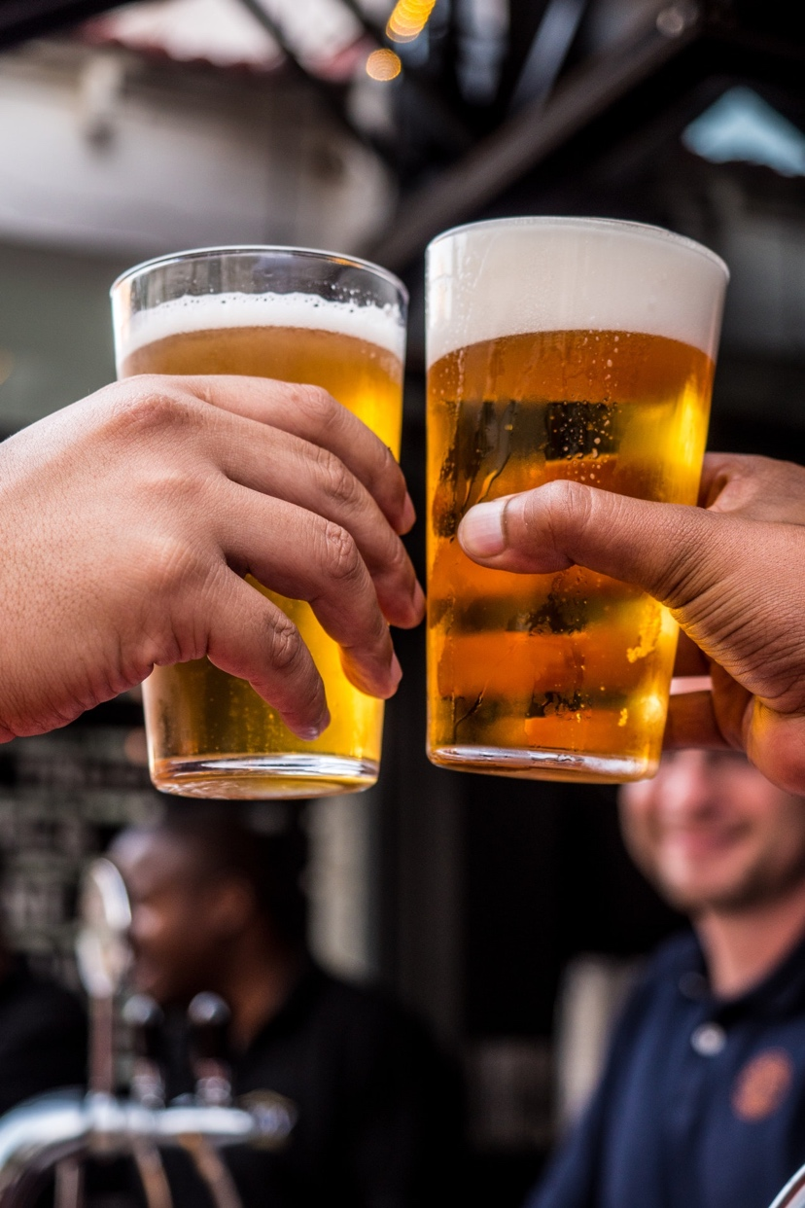

Table of Contents
Executive Summary 3
Mission Statement 3
Distinctives 3
Investment Opportunities 3
Business Description 3
Legal Structure 3
Location 3
Launch 4
Sources of Revenue 4
Operations & Management 4
Leadership 4
Front of House Operations 4
Back of House Operations 4
Marketing 5
Beer Profile 5
Target Market 5
Promotional Outlets 5
SWOT Analysis 5
Competition 5
Financials 6
Startup Expenses 6
Sources of Funding 6
Financial Operations 6
Revenue Projections 6
Break Even Point 6
Pro Forma Profit and Loss Statement 6
Future Plans 6

Executive Summary
[Name of business] is a new brewery that will be established in [city/town] by founders [list names of founders]. The brewery will focus on providing high quality craft beer to patrons of the on-site taproom and to local restaurants.

Initially, [name of business] will be supported by a personal investment from each of the founders and a business loan that will be used to secure real estate and equipment.

Mission Statement
“[Business name] exists to create a selection of the finest craft beers for local consumption and to develop a space for community engagement.”

Distinctives
- Beer made using 90% local ingredients, with care taken to develop a close relationship with local farmers.
- The creation of a multi-use taproom that can be booked for concerts, private receptions, public speaking events, and more.
- Cooperative program with local community college to train students on brewing processes.

Investment Opportunities
Although [business name] has enough capital to begin brewing on a small scale, capital from private investors in the brewery will be needed to purchase additional equipment, customize a taproom space, and hire employees. This will be achieved through a combination of loans, memberships, and equity partnerships.

Business Description
Legal Structure
[Business name] has been established as a Limited Liability Company in the state of [State name]. [Name] is the attorney of record.

Location
A location for [Business name] has not yet been found. To reduce upfront costs, the goal is to lease a commercial unit that has a combination of warehouse space for brewing and retail frontage with pedestrian access for the development of a taproom.

Launch
Pending finances and the lease of a suitable space for brewing, [business name] will tentatively open its doors to customers on/in [note specific date or month with year].
Sources of Revenue
[Business name’s] primary source of revenue will be derived from beer sales directly to the customer in the taproom. Secondary sources of revenue include wholesale beer sales to bars/restaurants, and booking fees for use of the taproom space.

Operations & Management

Leadership
CEO – [Name and brief bio]
CFO – [Name and brief bio]
Director of Marketing – [Name and brief bio]
Master Brewer – [Name and brief bio]
Administrator – [Name and brief bio]

Front of House Operations
Taproom Manager – The Taproom Manager will be responsible for supervising service in the brewery taproom. This includes hiring servers/bartenders, scheduling shifts, displaying products, rotating taps, and ensuring that the taproom premises complies with health and safety codes at all times.
Back of House Operations
Brewery Manager – The Brewery Manager will work in conjunction with the Master Brewer to maintain all aspects of production in the brewery, from quality control to shift scheduling to maintenance and cleaning procedures. The Brewery Manager will also be expected to regularly inspect equipment and ensure the security of all brewing operations in accordance with local health and safety regulations.

Marketing

Beer Profile

Target Market

Promotional Outlets
    - Social Media
    - Collaborative Brews
    - Press/Media Coverage
    - Release Parties
    - Loyalty Incentives
    - Merchandise
    - Charity
    - Local Ingredients

SWOT Analysis
    - Strengths
    - Weaknesses
    - Opportunities
    - Threats
    - Summary
Strengths | Weaknesses | Threats | Opportunities

Competition
According to The Brewer’s Association, craft beer production volume increased by 3.9% nationally in 2018. Craft beer now represents $26.6 billion in the domestic beer market (31.5%). There are over 7,000 breweries in the United States, with the majority being craft breweries.

In the state of [state name], there are [number] craft breweries. More specifically, within the local market of [city/town/municipality/county] we have identified [number] existing breweries:

- [Brewery name] – Brief description.
- [Brewery name] – Brief description.
- [Brewery name] – Brief description.

Financials

Startup Expenses

Sources of Funding
Use our Sources and Uses spreadsheet to complete this section.

Financial Operations
- Property Rental
- Hours of Operation
- Staffing
- Professional Services
- Cost of Beverages Sold

Revenue Projections

Break Even Point
[Brewery name] will break even when it achieves sales of [$] per month.
Pro Forma Profit and Loss Statement
Use our Pro Forma Profit and Loss spreadsheet to complete this section.

Future Plans
You can use this section to describe any plans that you have for expansion once your brewery has covered all opening costs and is able to maintain a strong cash flow from one month to the next.

Future plans may include:
- Hiring more staff
- Adding a canning/bottling line to your facility
- Expanding your building
- Opening a second location
- Purchasing more equipment to increase your brewing capacity
- Adding a full kitchen to your taproom

