Barbershop Business Plan
Provided by TheSMBGuide
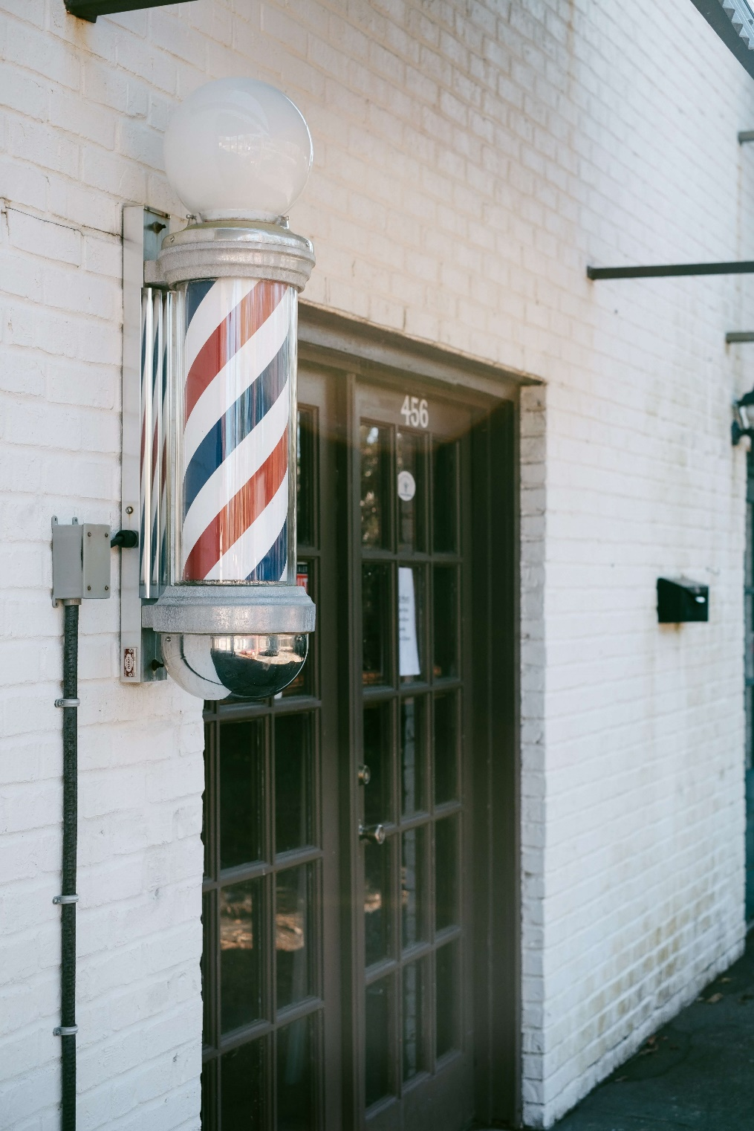

Table of Contents
Executive Summary 3
Mission Statement 3
Distinctives 3
Investment Opportunities 3
Business Description 3
Legal Structure 3
Location 3
Launch 4
Sources of Revenue 4
Operations & Management 4
Leadership 4
Role of the owner 4
Role of the manager 4
Team 4
Marketing 5
Genre Profile 5
Target Market 5
Promotional Outlets 5
SWOT Analysis 5
Competition 5
Financials 6
Startup Expenses 6
Sources of Funding 6
Financial Operations 6
Revenue Projections 6
Break Even Point 6
Pro Forma Profit and Loss Statement 6
Future Plans 6

Executive Summary
[Name of business] is a new barbershop that will be established in [city/town] by founders [list names of founders]. The company will focus on providing high quality barbering services and grooming products to customers.

Initially, [name of business] will be supported by a personal investment from each of the founders and a business loan that will be used to secure real estate and equipment.

Mission Statement
“[Business name] exists to offer a selection of the finest barbering services using the best quality products in a comfortable and welcoming upmarket shop.”

Distinctives
- Use and sell only organic grooming products.
- Young barber training program.

Investment Opportunities
Although [business name] has enough capital to begin offering at-home services on a small scale, capital from private investors is needed to purchase additional equipment, lease property, and hire employees. This will be achieved through a combination of loans, memberships, and equity partnerships.

Business Description

Legal Structure
[Business name] has been established as a Limited Liability Company in the state of [State name]. [Name] is the attorney of record.

Location
A location for [Business name] has not yet been found. To increase walk-in business, the goal is to lease a commercial unit in an upmarket area, where there is a lot of foot traffic and consumer activity.

Launch
Pending finances and the lease of a suitable space for the barbershop, [business name] will launch its services on [note specific date or month with year].
Sources of Revenue
[Business name’s] primary source of revenue will be derived from cutting, styling and grooming hair. Secondary sources of revenue include the sales of organic grooming products, and the import of barbering tools to sell to other barbers.

Operations & Management

Leadership
Owner – [Name and brief bio]
Manager – [Name and brief bio]

Role of the Owner
The owner will negotiate contracts, liaise with stakeholders and partners, source products and tools, market the shop, and manage the growth strategy of the barbershop.

Role of the Manager
The manager will manage the team, assign shifts, ensure the shop runs smoothly, monitor processes and procedures, ensure a high-level of hygiene is maintained, monitor inventory, and report to the owner.

Team
The team will consist of six barbers, a receptionist, two cleaning staff, a shoe shine person, and a barista for the coffee station.

Marketing

Genre Profile

Target Market

Promotional Outlets
    - Social Media
    - Barbering Conferences
    - Press/Media Coverage
    - Pamphlets
    - Loyalty Incentives
    - Discounts
    - Charity

SWOT Analysis
    - Strengths
    - Weaknesses
    - Opportunities
    - Threats
    - Summary
Strengths | Weaknesses | Threats | Opportunities

Competition
According to reports, the barbershop industry is expected to reach total revenues of $910 million in 2020, and the men's grooming industry as a whole could reach an estimated $26 billion by 2020. Consumer surveys say that 44% of men prefer going to a barber, and 71% stay with a specific barber for up to seven years.

In the state of [state name], there are [number] barbershops. More specifically, within the local market of [city/town/municipality/county] we have identified [number] existing barbershops:

- [Barbershop name] – Brief description.
- [Barbershop name] – Brief description.
- [Barbershop name] – Brief description.

Financials

Startup Expenses

Sources of Funding
Use our Sources and Uses spreadsheet to complete this section.

Financial Operations
- Property Rental
- Hours of Operation
- Staffing
- Professional Services

Revenue Projections

Break Even Point
[Barbershop name] will break even when it achieves sales of [$] per month.
Pro Forma Profit and Loss Statement
Use our Pro Forma Profit and Loss spreadsheet to complete this section.

Future Plans
You can use this section to describe any plans that you have for expansion once your company has covered all opening costs and is able to maintain a strong cash flow from one month to the next.

Future plans may include:
- Hiring more staff
- Opening a second shop
- Offering mobile barbering services

