Pizza Shop Business Plan
Provided by TheSMBGuide
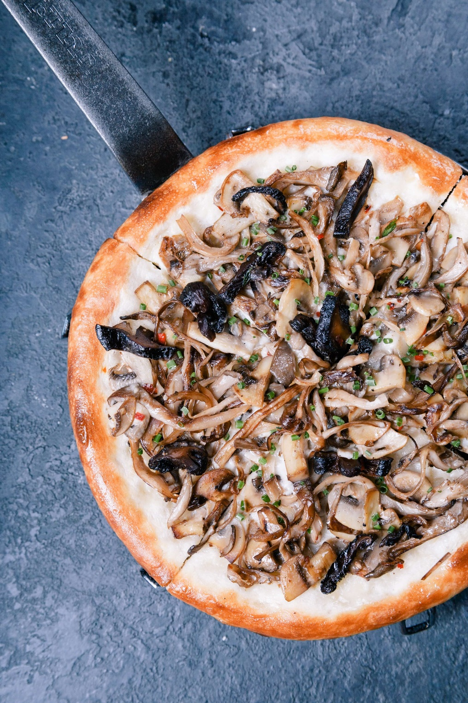

Table of Contents
Executive Summary 3
Mission Statement 3
Distinctives 3
Investment Opportunities 3
Business Description 3
Legal Structure 3
Location 3
Launch 4
Sources of Revenue 4
Operations & Management 4
Leadership 4
Role of the Owner 4
Role of the Manager 4
Team 4
Marketing 5
Genre Profile 5
Target Market 5
Promotional Outlets 5
SWOT Analysis 5
Competition 5
Financials 6
Startup Expenses 6
Sources of Funding 6
Financial Operations 6
Revenue Projections 6
Break Even Point 6
Pro Forma Profit and Loss Statement 6
Future Plans 6

Executive Summary
[Name of business] is a new pizza shop that will be established in [city/town] by founders [list names of founders]. The company will focus on providing high-quality service, and authentic New York-style pizza.

Initially, [name of business] will be supported by a personal investment from each of the founders and a business loan that will be used to secure real estate and equipment.

Mission Statement
“[Business name] exists to offer the best pizza-night out, with world-class service and old speak-easy atmosphere.”

Distinctives
- We follow family recipes.
- Host live events.
- Use organic ingredients, sourced as nearby as possible.

Investment Opportunities
Although [business name] has enough capital to open the doors to customers, capital from private investors will be needed to purchase additional equipment, furnish the shop, and hire employees. This will be achieved through a combination of loans, memberships, and equity partnerships.

Business Description

Legal Structure
[Business name] has been established as a Limited Liability Company in the state of [State name]. [Name] is the attorney of record.

Location
A location for [Business name] has been found. It is a [square footage] shop in [location]. The area has many coffee shops, clothing stores, art galleries, and tourist destinations.

Launch
Pending finances and a full staff, [business name] will open its doors to the public in/on [note specific date or month with year].
Sources of Revenue
[Business name’s] primary source of revenue will be derived from the sale of pizza and craft beer. Secondary sources of revenue include sales of unique in-house sauces, and live music events.

Operations & Management

Leadership
CEO – [Name and brief bio]
CFO – [Name and brief bio]
Master Chef – [Name and brief bio]

Front of House Operations
Pizza Shop Manager – The Pizza Shop Manager will be responsible for supervising service in the pizza shop. This includes hiring servers/bartenders, scheduling shifts, displaying products, and ensuring that the premises complies with health and safety codes at all times.
Back of House Operations
Kitchen Manager – The Kitchen Manager will work in conjunction with the Master Chef to maintain all aspects of food preparation, from quality control to shift scheduling to maintenance and cleaning procedures. The Kitchen Manager will also be expected to regularly inspect equipment and ensure the kitchen adheres to all local health and safety regulations.

Marketing

Pizza Profile

Target Market

Promotional Outlets
    - Social Media
    - Industry Events
    - Press/Media Coverage
    - Online Ordering
    - Loyalty Incentives
    - Selfie Corner
    - Charity

SWOT Analysis
    - Strengths
    - Weaknesses
    - Opportunities
    - Threats
    - Summary
Strengths | Weaknesses | Threats | Opportunities

Competition
In 2018, the pizza industry’s total revenue was $45.1 billion, of which chains constituted 58.9% and independents 41.1%. It is expected to reach a total annual revenue of $47.2 billion by 2023. There were roughly 75,000 pizza businesses in the U.S. in 2018, with over 5,000 of them closing their doors.

In the state of [state name], there are [number] pizza shops. More specifically, within the local market of [city/town/municipality/county] we have identified [number] existing pizza shops:

- [Pizza shop] – Brief description.
- [Pizza shop] – Brief description.
- [Pizza shop] – Brief description.

Financials

Startup Expenses

Sources of Funding
Use our Sources and Uses spreadsheet to complete this section.

Financial Operations
- Property Rental
- Hours of Operation
- Staffing
- Professional Services
- Cost of Services

Revenue Projections

Break Even Point
[Pizza shop name] will break even when it achieves sales of [$] per month.
Pro Forma Profit and Loss Statement
Use our Pro Forma Profit and Loss spreadsheet to complete this section.

Future Plans
You can use this section to describe any plans that you have for expansion once your company has covered all opening costs and is able to maintain a strong cash flow from one month to the next.
Future plans may include:
- Hiring more staff
- Expanding to second location

